Error:

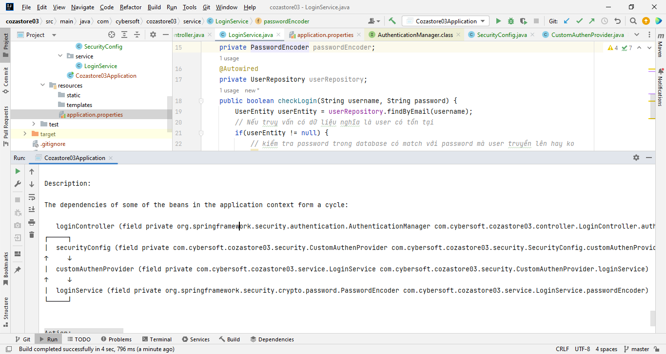

Solution 1: Thêm

@Lazy

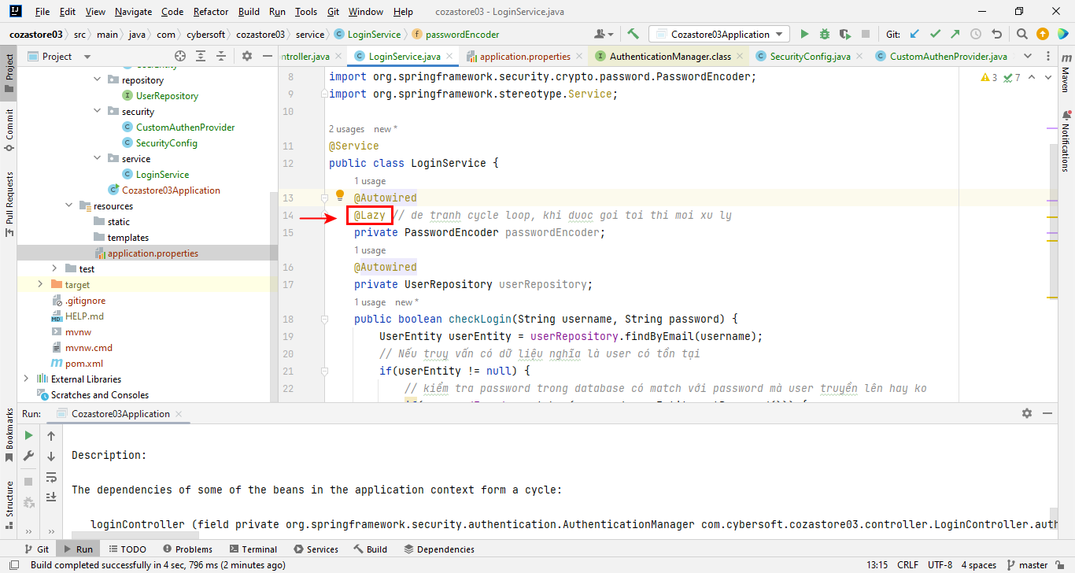

Cách 2: Thêm config sau vào application.properties

spring.main.allow-circular-references = true

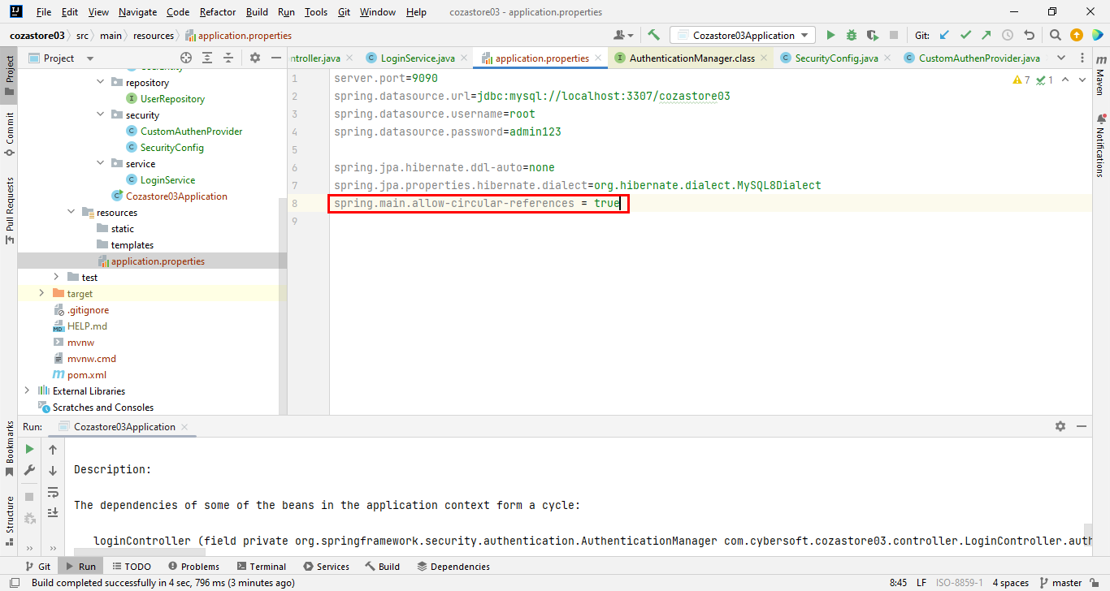

2023-11-21 20:37:05.493 INFO 10136 --- [ main] j.LocalContainerEntityManagerFactoryBean : Closing JPA EntityManagerFactory for persistence unit 'default'

2023-11-21 20:37:05.503 INFO 10136 --- [ main] o.apache.catalina.core.StandardService : Stopping service [Tomcat]

2023-11-21 20:37:05.526 INFO 10136 --- [ main] ConditionEvaluationReportLoggingListener :

Error starting ApplicationContext. To display the conditions report re-run your application with 'debug' enabled.

2023-11-21 20:37:05.566 ERROR 10136 --- [ main] o.s.b.d.LoggingFailureAnalysisReporter :

\*\*\*\*\*\*\*\*\*\*\*\*\*\*\*\*\*\*\*\*\*\*\*\*\*\*\*

APPLICATION FAILED TO START

\*\*\*\*\*\*\*\*\*\*\*\*\*\*\*\*\*\*\*\*\*\*\*\*\*\*\*

Description:

The dependencies of some of the beans in the application context form a cycle:

loginController (field private org.springframework.security.authentication.AuthenticationManager com.cybersoft.cozastore03.controller.LoginController.authenticationManager)

┌─────┐

| securityConfig (field private com.cybersoft.cozastore03.security.CustomAuthenProvider com.cybersoft.cozastore03.security.SecurityConfig.customAuthenProvider)

↑ ↓

| customAuthenProvider (field private com.cybersoft.cozastore03.service.LoginService com.cybersoft.cozastore03.security.CustomAuthenProvider.loginService)

↑ ↓

| loginService (field private org.springframework.security.crypto.password.PasswordEncoder com.cybersoft.cozastore03.service.LoginService.passwordEncoder)

└─────┘

Action:

Relying upon circular references is discouraged and they are prohibited by default. Update your application to remove the dependency cycle between beans. As a last resort, it may be possible to break the cycle automatically by setting spring.main.allow-circular-references to true.

Process finished with exit code 1